**Assignment No. 3**

1. **Fork the finance application repository from GitHub.**

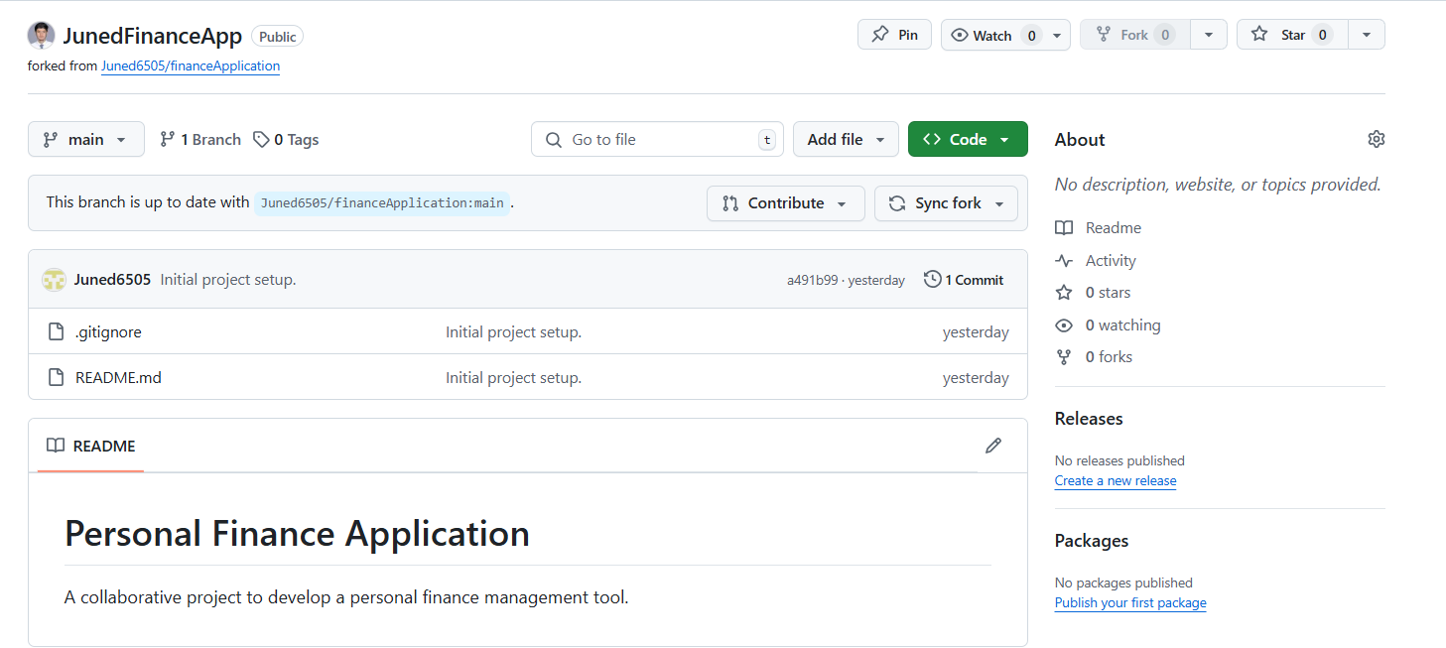

1. **Clone the forked repository to your local machine.**

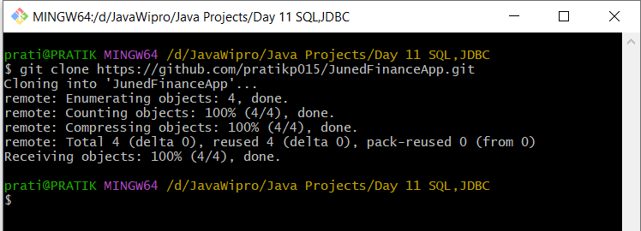

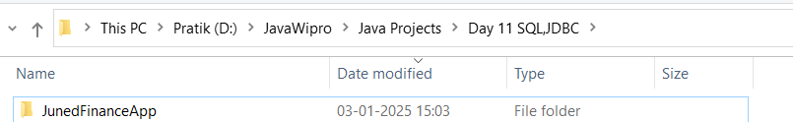

1. **Create a new branch called localization-support**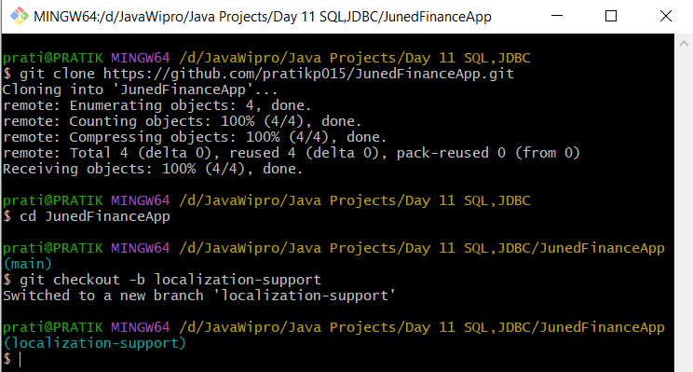

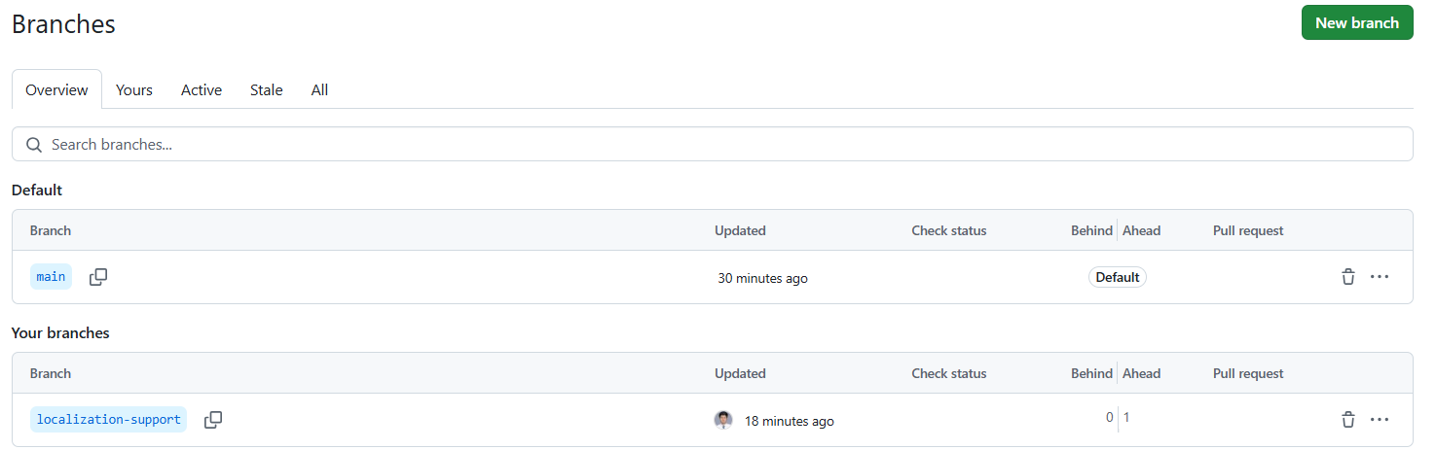

1. **Simulate localization changes by adding a translations.md file.**

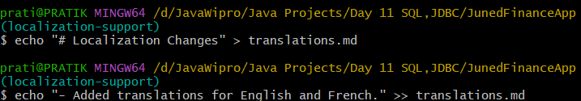

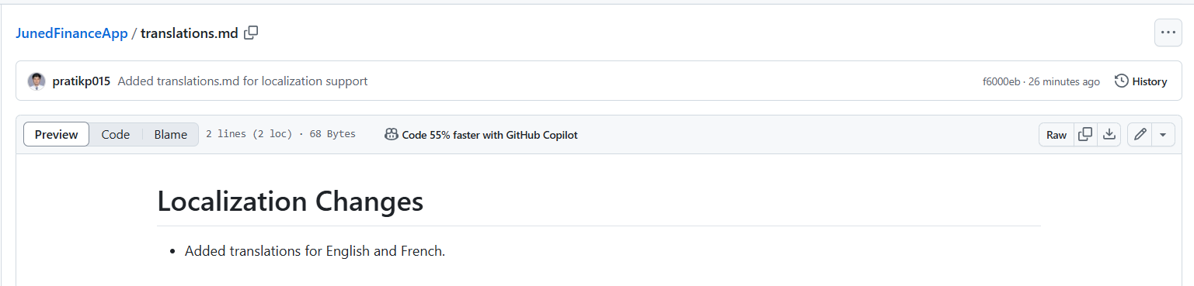

1. **Commit and push the changes to your fork.**

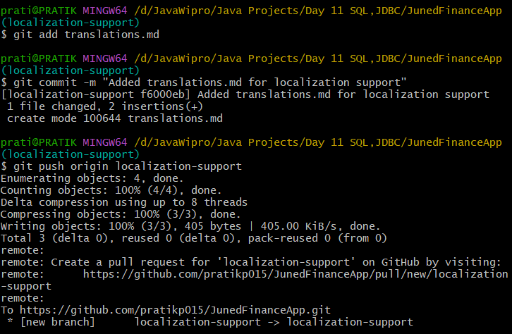

1. **Open a pull request to merge changes into the main repository.**

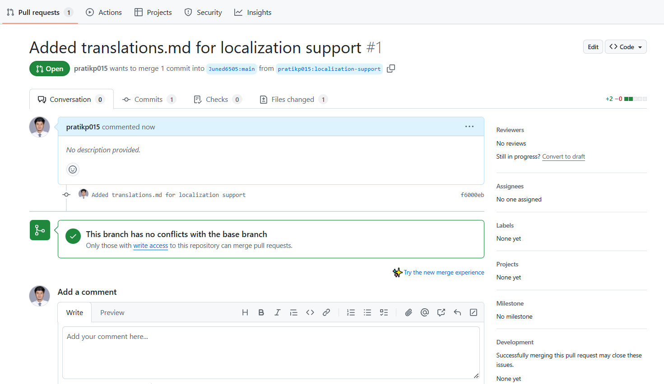

1. **Tag the current state of the main branch as v1.0.0 and push the tag to GitHub.**

